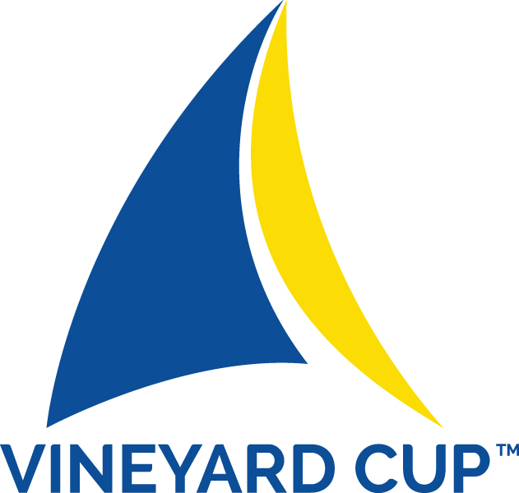



THE VINEYARD CUP
FOILING and BIG AIR CHAMPIONSHIP

September 29, 2016 to October 2, 2016
MARTHA’S VINEYARD ISLAND, MASSACHUSETTS

NOTICE OF RACE
Amended August 8, 2016

Sail Martha’s Vineyard is pleased to invite kiteboard sailors to take part in the American Kiteboard Association sanctioned Vineyard Cup Foiling and Big Air Kiteboard Championships between the dates of September 29, 2016 to October 2, 2016

- 1 RULES
  - The regatta will be governed by the Rules as defined in The Racing Rules of Sailing 2013‐2016 (RRS) including Appendix F – Kiteboard Racing Rules.
  - The IKA Class Rules.
  - Only the following US SAILING prescriptions will apply: the prescriptions to Rules 68, 76.1, and 76.3.
- ADVERTISING
  - The Cup will be sailed in accordance with ISAF Regulation 20.3.1(b)
  - Competitors may be asked to display a sponsors’ flag provided by the Organizing Authority as permitted by ISAF regulation 20.3 (d)(i)
- ENTRY AND ELIGIBILITY
  - The regatta is open to equipment competing in the Foiling Division
  - The regatta is open to competitors in the Big Air Division
  - The entry application deadline is 1800 hrs EDT September 27, 2016.
  - ENTRIES WILL BE LIMITED TO 50 COMPETITORS
    - If registrations exceed 50, the competing fifty competitors may be chosen by resume or the competitor limit increased.
  - Each sailor shall register using the official online application form at www.vineyardcup.com
  - The following entry and qualification restrictions apply:
    - Evidence of valid third party insurance – minimum $1 million USD
    - Proof of age
    - Parental/legal Guardian Assent - for those under age of 18
    - Medical Treatment Permission - for those under age of 18 or on their parents medical insurance policy
    - Caddies, coaches and team support personnel shall provide the following documentation prior to completing registration formalities on site:
      - Boat Driving License (if applicable)
      - Evidence of valid third party insurance for drivers of coach boats – minimum $5 million USD
    - Check-in will take place at the offices of Sail Martha’s Vineyard at 79 Beach Road, Vineyard Haven on September 27, 2016 between 1200 EDT and 1700 EDT
    - A late check-in at State Beach, Oak Bluffs may be provided before racing on Wednesday, September 28, 2016.
- FEES
  - The entry fee is $75, if registered no later than September 20, 2016
  - The entry fee will be $100 for those registering after September 20th.
  - A late fee of $50 will be applied to all competitors who register after the September 27th deadline
  - The coach entry fee is $35
  - A 50% refund will be given to registrants who provide notification of their intent not to compete if accompanied by a medical certificate issued by a medical doctor stating a valid reason why the competitor cannot compete. by 1800 EDT September 27, 2016
- PRELIMINARY SCHEDULE
  - Thursday, September 29, 2016
    - Check In 0900 EDT to 1000 EDT
    - Competitors Meeting 1030 EDT
    - Distance Race First Warning Signal 1300 EDT
    - Competitors Opening Party 1800 EDT
  - Friday, September 30, 2016
    - Check In 0900 EDT to 1000 EDT
Buoy Races First Warning Signal 1300 EDT
    - Competitors Post Race Party 1800 EDT
  - Saturday, October 1, 2016
    - Buoy Races First Warning Signal 1200 EDT
    - Competitors Post Race Party 1800 EDT
  - Sunday, October 2, 2016
    - Buoy Races First Warning Signal 1200 EDT
    - Awards Ceremony and Party 1700 EDT

NOTE #1: The Race Committee may call for earlier first gun times if conditions and forecast warrant.
NOTE #2: On Sunday, July 12th no warning signal will be made after 1600 hrs
NOTE #3: Big Air heats will be interspersed with Foiling heats to allow competitors entered in both Divisions to compete

- SAILING INSTRUCTIONS
  - Sailing Instructions will be posted on the Vineyard Cup website and be available at Race Headquarters beginning at 0900 hrs EDT on September 26, 2016 and at the Competitors Meeting
- RACE HEADQUARTERS
  - Race Headquarters will be located at Sail Martha’s Vineyard’s offices at 79 Beach Road, Vineyard Haven
- RACING VENUE
  - All racing will take place on the waters of Cow Bay along State Beach
- ON SITE STORAGE
  - Storage containers will be available at the launch site
- COURSES
  - There will be four basic course designs for the Foiling Division:
      - Friday, September 30, 2016 Distance Coastal Race
      - Saturday and Sunday, October 1-2, 2016 Buoy Races
      - Modified windward leeward
      - Windward leeward with reaching final leg to finish line perpendicular to starting line
      - Windward leeward slalom with leeward gate
  - The Big Air Division heats will be sailed on courses parallel to the beach
- PENALTY SYSTEM
  - The Penalty System of RRS 44 as amended through the Sailing Instructions will apply. The penalty turn requires a tack and a gybe. This changes RRS F44.2
  - The Sailing Instructions may provide for the Rule 44.3 scoring penalty option
- SCORING
  - The Foiling Distance Race on Thursday, September 29, 2016 will NOT count towards the prize money. Separate Awards will be made.
  - At least five buoy races must be completed in order to constitute the regatta series for the Foiling Division
  - The low point system of Appendix A will apply
  - Competitors in the Big Air Division will be scored using a Woo Sports Device, measuring height, hang time and landing G forces
- PRIZES
  - Awards will be made to the top three finishers in the Distance Coastal race
  - TOTAL prize money for the Buoy Races will be $10,000 and will be awarded as follows:
    - First place will receive $2,500
    - Second place will receive $1,800
    - Third place will receive $1,300
    - Fourth place will receive $750
    - Fifth place will receive $500
    - Sixth place will receive $400
    - Seventh place will receive $300
    - Eighth Place will receive $200
    - Ninth place will receive $150
    - Tenth place will receive $100
    - TOP WOMAN $1,500
    - TOP JUNIOR (UNDER 18) $500
  - Awards will be made to the top three finishers in each category of the Big Air Division

- IDENTIFICATION
  - Every competitor is required to wear the official event jersey with his/her personal identification number whenever competing.
- SAFETY
  - As per RRS 4 the decision to race rests solely with the competitor or his/her guardian, if the competitor is under the age of 18
  - All competitors shall wear personal flotation devices and helmets while racing
  - All support personnel shall wear personal flotation devices at all times when on the water
  - If the water temperature is below 64° F, competitors are strongly encouraged to wear a wetsuit.
- LIABILITY
  - The safety of a competitor’s equipment is the sole and inescapable responsibility of the competitor
  - Each participant also agrees to relieve from any responsibility or liability Sail Martha’s Vineyard, its Directors, employees, volunteers, members, agents and sponsors and their representatives in respect of any claim arising from participation in the Vineyard Cup, to include loss of life, injury or loss of or damage to any vessel or property.
- MEDIA RELEASE
  - Competitors and crewmembers grant, at no cost, Sail Martha’s Vineyard the absolute right and permission to use their name, voice, image, likeness, biographical material; as well as representations of the boats in any media (including but not limited to television, print and internet media), including video footage, for the sole purpose of advertising, promoting and disseminating information regarding the Vineyard Cup and Sail Martha’s Vineyard and its programs.
- FURTHER INFORMATION
  - For further information please contact the Sail Martha’s Vineyard at 1.508.696.7644 or bcallen@sailmv.org or visit www.vineyardcup.com
- CHANGES TO THIS NOTICE OF RACE
  - Sail Martha’s Vineyard reserves the right to amend this notice. Any amendment(s) to this notice will be posted on the Vineyard Cup website and every effort will be made to notify registered competitors of the change.

